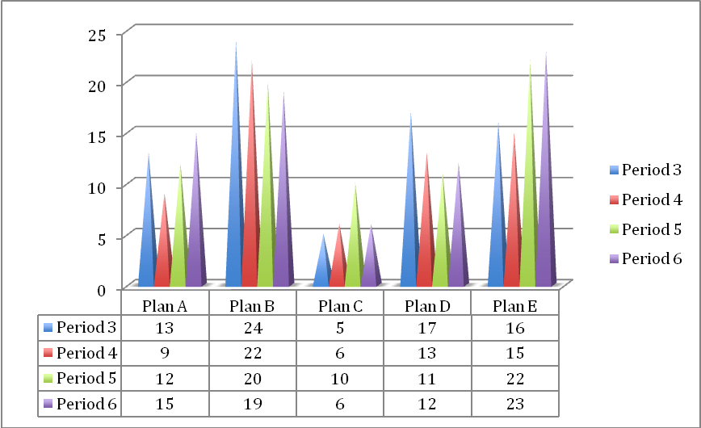

|  |  |  |  |  |
| --- | --- | --- | --- | --- |
| Plan A | Plan B | Plan C | Plan D | Plan E |
| Tell people to save for their own retirement | 65+ pension bonus for working extra years | Pay relatives to help elders | Encourage companies to pay for healthcare | Others |

**Interpretation**

It is clear from this graph that Period 3 thought that Plan B is the best plan and Plan C is the worst plan. Similarly, Period 4 thought that Plan B is the best plan and Plan C is the worst plan. However, Period 5 thought that Plan E was the best plan and they thought that Plan C was the worst plan. Period 6 thought that Plan E was the best plan and that Plan C was the worst plan.